The methods in the files are coded by Zhiming Liu.

The code is nearly passed the PEP8 inspection within PyCharm IDE.

# Controller.py

**Realised Methods:**

* __init__()
* Do_select()
* Do_add()
* Do_import()
* Do_export()
* import_row()
* Do_save()
* Do_show()
* Show_pie()
* Show_bar()
* Help_show()
* Help_add()
* Help_save()
* Help_select()
* Help_import()
* Help_export()

**PEP8 Inspection Result:**

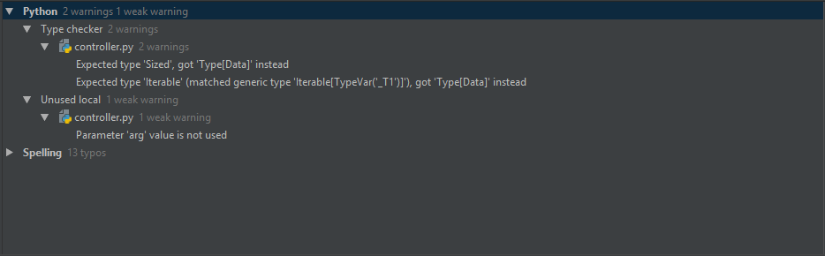

# Csv_operations.py

**Realised Methods:**

* __init__()
* Create_file()
* Read()
* File_exist()
* Save()

**PEP8 Inspection Result:**

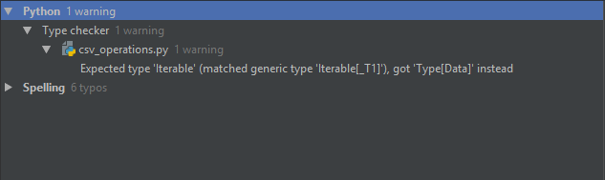

# Data.py

**Realised Methods:**

* All the code

**PEP8 Inspection Result:**

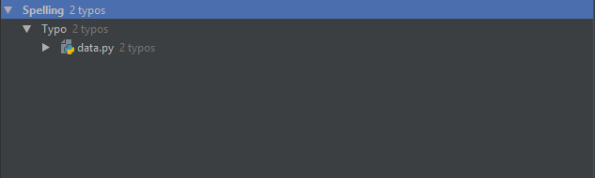

# Data_validator.py

**Realised Methods:**

* __init__()
* Check_gender()
* Check_sales()
* Check_bmi()
* Check_salary()
* Check_birthday()
* Check_all()

**PEP8 Inspection Result:**

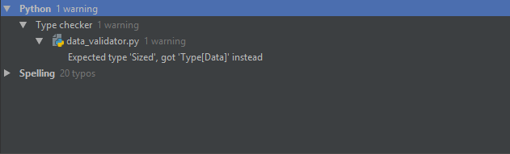

# Idata_access.py

**Realised Methods:**

* Read()
* Write()

**PEP8 Inspection Result:**



# Iview.py

**Realised Methods:**

* Display()
* Error()
* Success()
* Warning()
* Info()
* Display_data()
* Import_result_header()
* Import_result_row()
* Plot_pie()
* Plot_bar()
* Plot_barh()
* Help_show()
* Help_select()
* Help_add()
* Help_import()
* Help_save()
* Help_quit()
* Help_export()

**PEP8 Inspection Result:**

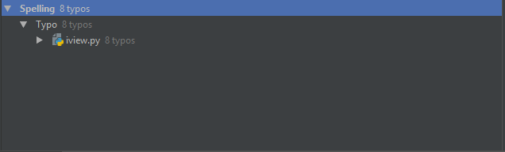

# View_console.py

**Realised Methods:**

* Display()
* Error()
* Success()
* Warning()
* Info()
* Display_data()
* Import_result_header()
* Import_result_row()
* Plot_pie()
* Plot_bar()
* Plot_barh()
* Help_show()
* Help_add()
* Help_save()
* Help_select()
* Help_show()
* Help_select()
* Help_add()
* Help_import()
* Help_save()
* Help_quit()
* Help_export()

**PEP8 Inspection Result:**



# Staff_data.py

**Realised Methods:**

* __init()__
* Select_source()
* Load_data()
* Add_data()
* Data_exist()
* Save_data()
* Get_all_data()
* Get_gender()
* Get_bmi()
* __del__()

**PEP8 Inspection Result:**

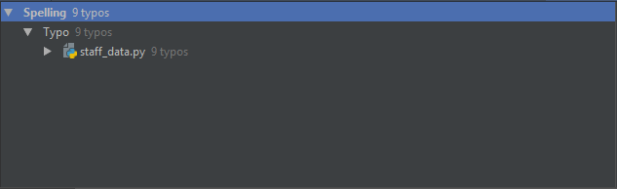

# Pickle_operations.py

**Realised Methods:**

Pickle_dump()

Pickle_import()

Pickle_path()

**PEP8 Inspection Result:**

